**Stefan Prins**

**Nationality:** Netherlands / French **Current Location:** Berkel en Rodenrijs.

**Date & Place of birth:** 16/06/1988. Rotterdam, NL.

**Phone:** +31 610590615 **E-mail:** [prinsav@live.nl](mailto:prinsav@live.nl)

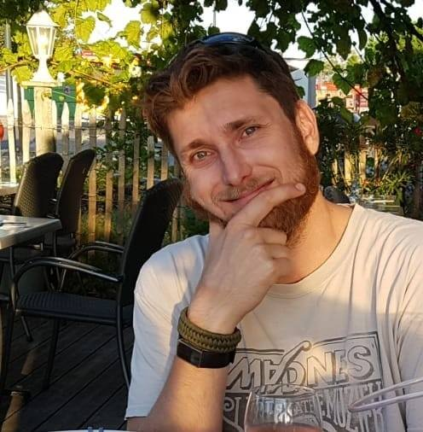

**Prins AV** (Founder). > KVK 51419580

*2010 – actual. Rotterdam, NL.*

As the founder and lead technician of my own audio-visual installation company,

I have over 15 years of experience delivering high-quality AV solutions for both private and commercial clients. My work encompasses the full project cycle from consultation to installation, testing, and support.

I work closely with my clients to find the best solutions to their specific needs, ensuring functionality and user-friendly operation. In addition to AV installations, I have extensive experience in live sound and event production, supporting music festivals and bands.

**STRENGTH SKILLS:**

Creativity, attention to detail, professional, perseverance, problem solving.

**EXPERTISE SUMMAR:**

* **System Design & Consultation**: Collaborate directly with clients, architects, interior designers, and contractors to design AV systems that meet functional needs and design preferences. Conduct site evaluations and develop customized installation plans for optimal performance and integration.
* **AV Installations**: Execute professional installation multi-room audio/video systems, video conferencing solutions, control systems, projectors, led walls, array systems, and acoustical treatments.
* **Commercial Solutions**: Deliver scalable AV installations for retail environments, restaurants, hospitality and cultural venues. Specialize in video walls, distributed audio, digital signage, and networked AV over IP.
* **Structured Cabling**: Install data infrastructure including CAT cabling, rack systems, network switches, and routers to ensure seamless integration of AV and IT systems.
* **Troubleshooting & Support**: Provide comprehensive system testing, user training, ongoing maintenance, to ensure long-term satisfaction and reliability.
* **Sound Engineer for Live Events, Festivals & Bands.** Full-scale setup and operation of professional PA systems, stage monitors, and digital mixing consoles for multi-act lineups.
* **Theatrical & Architectural Lighting Setup.** Designing, installing, and configuring theatrical and architectural lighting systems to enhance stage performances, events, and interior environments.

**KEY PROJECTS:**

* **Yachting.** Vlissingen, NL
* Installing sophisticated AV solutions on luxury yachts, with meticulous attention to detail to protect premium materials and custom interiors, where performance, discretion, and durability are essential.
* Installations include multi-zone entertainment systems, satellite TV and internet, onboard theaters.
* *Custom Rack Design & Cable Management.* Installing compact, marine-grade AV racks with careful attention to ventilation, vibration resistance, and tidy cable routing to ensure long-term reliability in demanding environments.
* *Discreet Equipment Integration.* Integrated speakers, displays, and control devices into luxury interiors with minimal visual impact, often concealing components within bespoke cabinetry, ceiling voids, or custom enclosures.
* **Museum Installations**. Rotterdam, NL
* *Interactive Exhibit Integrations.* Touchscreen displays, motion-activated audio stations, and sensor-based AV triggers to enhance visitor engagement through dynamic, interactive experiences.
* *Projection Mapping & Visuals.* Complex projection mapping installations across irregular surfaces, using different projectors, media servers and calibration tools.
* *High-Resolution Video Displays.* Large-format screens for continuous loop exhibits, synchronized multi-screen content, and archival video playback.
* *Audio Distribution for Exhibit Halls.* Multi-zone audio systems with directional and ambient speakers.
* *Lighting Control Integration.* Programmed DMX and smart lighting systems synchronized with AV content.
* *Centralized Control Systems.* User-friendly control solutions allowing museum staff to operate multiple AV components—media, lighting, sound—from intuitive interfaces such as tablets or touchscreen panels.
* *Sensitive and Adaptable Installation Techniques*. Non-invasive methods to install AV equipment in heritage buildings and around delicate artifacts, allowing easy reconfiguration or removal to accommodate future exhibitions and rotating displays.
* **Narrowcasting / AV installations**  Various Locations & Clients, EU.
* Focused on AV installations for retail, public spaces, advertising and corporate environments.
* Complete AV systems for executive boardrooms, meeting spaces, and huddle rooms. Integrated video conferencing interfaces.
* Commercial tailored displays across retail stores, lobbies, and shopping centers.
* AV solutions for offices, centralized music playback, and digital whiteboards for collaborative workspaces.
* Providing ongoing support, troubleshooting, firmware updates, and system reconfiguration as part of long-term service.
* **Live Events and Festivals.** Various Locations, NL
* Setting up, operating, and managing all sound equipment to ensure high-quality audio throughout the event. installing PA systems, microphones, stage monitors, and mixing consoles.
* Working in coordination with other technicians, stage managers, and venue crews to ensure seamless show execution and meet technical requirements.
* Managing both FOH (Front of House) and on-stage sound during live performances, working under pressure to deliver clean, balanced audio in dynamic environments.
* Utilizing high-performance AV equipment from leading manufacturers.

**EDUCATION:**

2001 – 2005 GrafischLyceum, Rotterdam VMBO.

2005 – 2008 Podium en Evenemententechniek.

**LANGUAGES:**

**Dutch** Native **English** Fluent **French** Fluent **Spanish** Intermediate **German** Intermediate

**COURSES & CERTIFICATES:**

VCA certificate.

Climbing certificate.

Driving license A, B.

High-worker certificate.

Diving certificate.

SVH certificate.